I’ve continued working with the Library of Congress, By the People project. Continuing from my last journal I’ve once again returned to the Theordore Roosevelt campaign they are running. This campaign specifically really reminded me of just how insane and built different Theordore Roosevelt truly was. One of the pages I was reading had to get me to stop and start googling time frames as I was quite interested and curious to learn.

Included here is the page in question: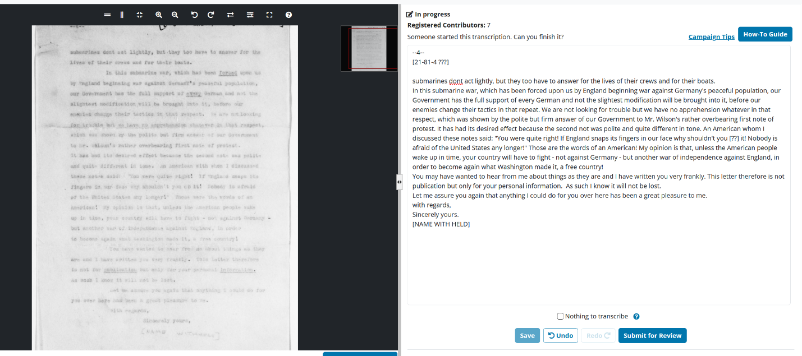

I was confused because I had to look it up and double check Teddy wasn’t even president at the time. People were mailing this man to discuss how we should align ourselves with in war time. People were that sure this man was boiling for war, and they were right Teddy was ready to lead troops personally into the front lines if they let him.

For my biggest connection to this class and future was a quite failed attempt at transcribing a page I saw on this page:

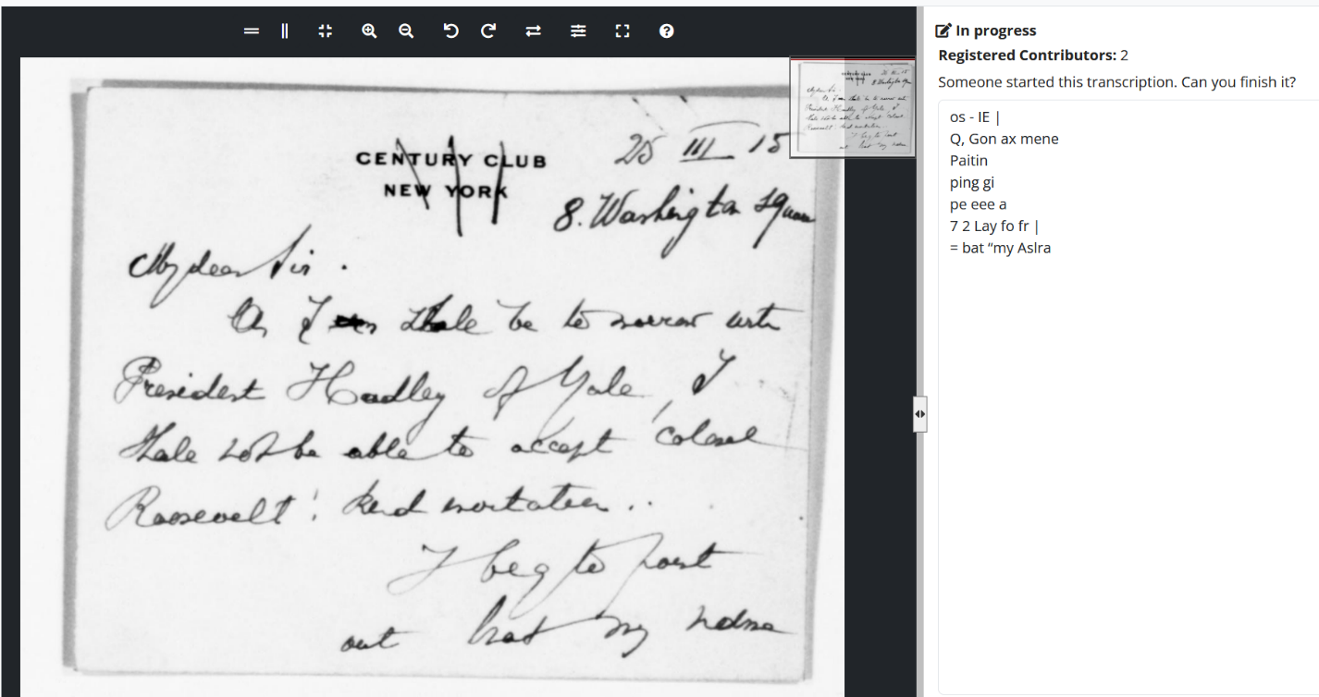

It’s sad to say but it will happen in the academic field people not trying or just giving up. Or the more likely issue is just trying to ruin this experience for everyone else. This should be a good reminder for my future endeavors and everyone else, that you will always have bad actors when your website is public. People do not care and will do whatever they can to pretend they’ve done something. Nowadays people turn to AI to get things done, it should be a good reminder that trying and putting in effort is worth something if not for a grade do it for yourself.